**DSC680 – Weight Training Strength to Weight Ratios**

**Joshua Burden**

**Bellevue University**

**04/16/2023**

**Abstract**

In the second term project I chose to examine the topic of weightlifting. As an avid gym goer, with a passion for lifting, I believed it would be interesting to discover what makes most happy at the gym, while discovering the natural theoretical limits of the human body under workloads and physical stress. This paper intends to discover the strength to weight ratio based on gender, age, and the most common exercises used for strength gain.

**Business Problem**

Weight training is a healthy and enjoyable experience. Getting into the gym could be daunting for some, but for many who have been training for years still might find that their performance is not adequate compared to others. This research paper is going to dive into the strength to weight ratios of an aggregate for many lifters, explore the most common exercises that many enjoy, and explore the data on the impact of gender age and weight for weightlifting.

**Datasets**

Data is limited for powerlifting, but from the datasets found the information that would be important is found such as height, weight, sex, level of intensity, and raw strength numbers. This data covers over 22,000 meets with 412,000 lifters from around the world. The data is as recent as April of 2019. Other datasets contain data used to track personal activity using wearable devices such as Jawbone Up, Nike Fuel Band, and Fitbit. One other set will contain information on weight and exercise movement prediction.

**Summary of Methods**

Methods would include bar charts, scatter plots, K-means clustering and other classification methods. It would also be interesting to see if there are other Indicators that might reveal some information on how the gender and age of a person affects the strength to weight ratio. Several regression tests will also be conducted to make charts that show the amount of change over a means of weight.

**Ethical Considerations**

Natural lifting is always an ethical concern, as a person under the influence of different pharmaceuticals could be creating a skewed strength to body weight ratio. Performance enhancing drugs often lead to premature death and many other terrible outcomes such as gynecomastia, mood swings, and unfair advantages in sports strength training. This could skew data heavily or suggest those who are older, stronger than their normal counterparts could be under the influence of steroids. These would be treated like outliers, but without the data of steroid use, it would be very difficult to tell thus making the accuracy of the results come into question.

**Challenges/Issues**

Data for this topic is prevalent but often regurgitated. Data that is aggregated is also very difficult to find as sports nutrition and other data points are often either kept secret or made public but very anecdotal in nature. Data points that seem to be outliers do come into question on whether the individual is genetically engineered, or genetically gifted by nature. Another concern is to know if the data contains an aggregate of the individual’s performance over time. As intensity and workload go up, there is more opportunities for injury or longer recovery which could show a lower overall strength to weight potential overall, and depending on the when the data was collected there could be a point that shows that the user was not at one hundred percent when the data was collected, giving a less than accurate picture overall.

**Findings**

Disecting the data provided a very interesting, however, not suprising set of results. Taking five selected data sets that ranged from weight training, body building, and powerlifting data sets from all over the world, several data points were able to be examined and visualized. The first set of information that was examined was a dataset that explored the various global weight lifting events from 1974 to 2018. 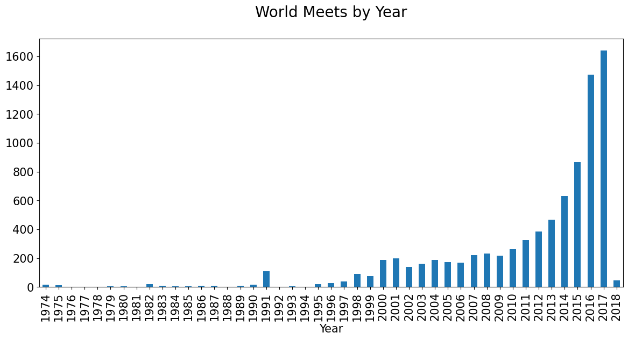

Consistantly year over year after 1999 bodybuilding and powerlifting meets increased significantly. This is not surprising since the rise of bodybuilding stemming from such legands as Arnold Schwartnegger, Ronnie Colman, and Lue Fragno. Something interesting was that world meets that occurred most often in these times based on month, was that there was a significant amount of world meets in the early part of the year. February had the greatest number of meets occuring, by almost 25% more than any other time in the year. The significance of this was more of a talking point than any statisical annomoly that carried any relevence to the data. 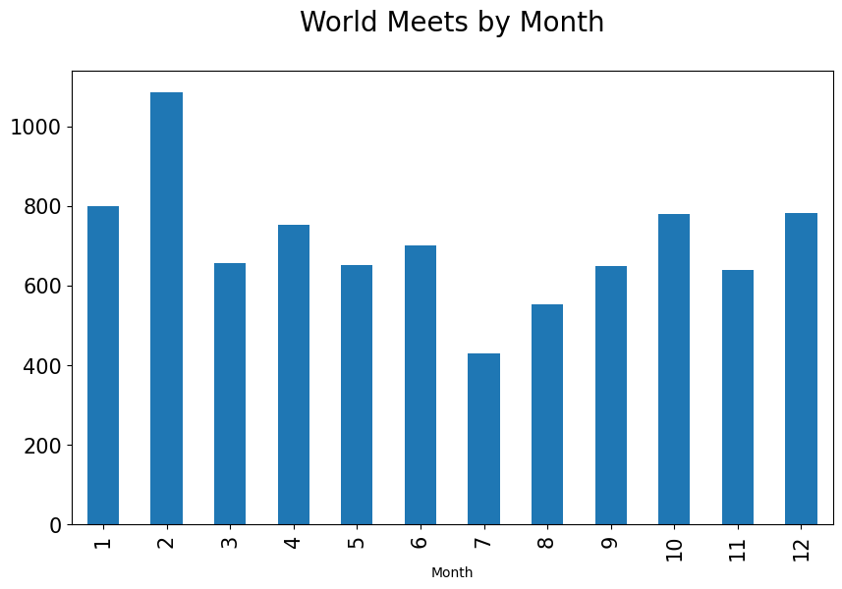

The amount of meets in the world occurred in the United States of America. This should not be a surprise considering the wealth distrubution between other countries GDP, and consdiering the population totals compared to other countries.

If we looked at the total amount of meets per one hundred thosand people on the otherhand we see that the United States actually had the least amount of meets per capita and other countries such as New Zealand, Austria and Canada having much higher count of meets per one hundred thosand people, meanwhile Norway having a staggering amount of meets incomparison than any other country. 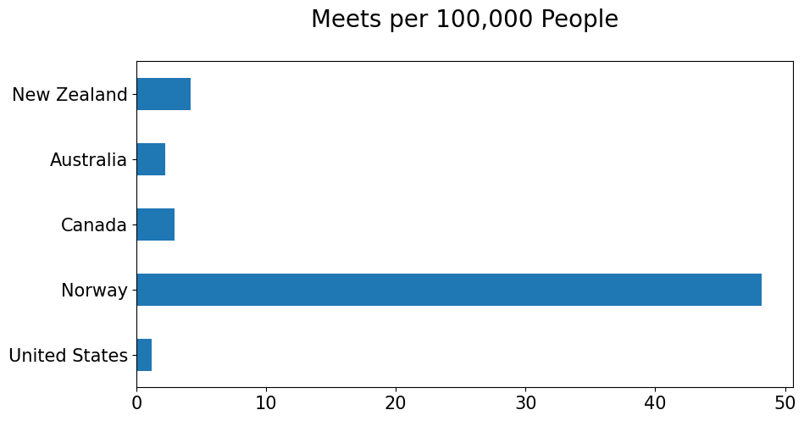

Within other datasets it was important to look at the strength differences between different ages, genders, body bodyweight, comparing these factors against the three main competitive lifts. The three benchmark compound lifts are the Deadlift, the Bench press, and the Squat. The Deadlift consists of a compound movement involving the large muscle groups working together to lift weight off the floor from a bent position into a standing position from a hip hinge. The muscle groups involved are the quadriceps, a group of muscles on the front of the legs, hamstrings a set of long muscles that run along the backside of the legs, the gluteus maximus a group of muscles commonly referred to as the buttocks, and primary back muscles such as the erector spinae. These muscles work in conjunction from taking a barbell with weight attached to it from a bent over position, knees bent back straight, to an upright position with the weight dragging up the shin and the hips pushed forward and the legs straight. When examining the deadlift, a record of all of the best deadlifts in kilograms based on gender, there was no surprise that men vastly out lifted women.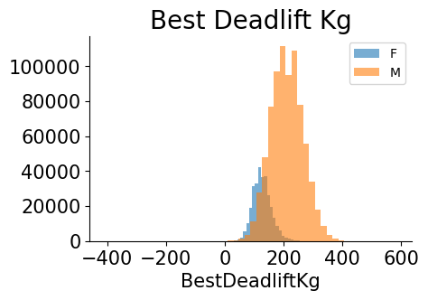

It was imperative as well to look at this data from the types of equipment been used meaning, we're wrap supplied to the wrists to strengthen the grip of the lifter and how did this impact the deadlift based on weight of the weightlifter based on the weight being lifted off the ground.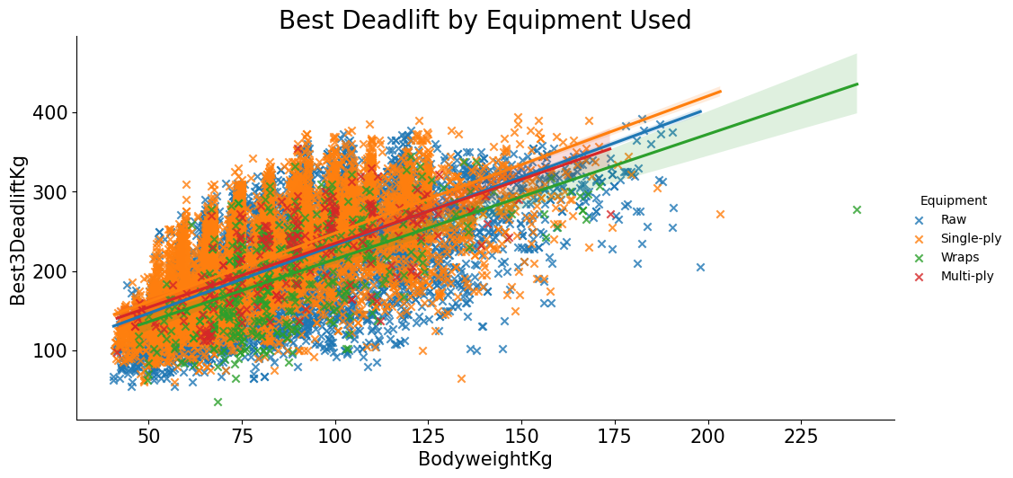

When examining the regression, single play equipment and the mass of the individual tended to have a more consistent clustering of data points than other types of equipment being used. One thing to make mention of, is that though the graph does represent a significant number of individuals using single ply equipment, one thing that happens with all individual data points is the larger the body of the individual in mass, the better the deadlift in kilograms was.

Next was looking into the bench press. The bench press is another compound movement that target the following muscles: pectoralis major: a large muscle in the upper chest, anterior deltoid a muscle found on the outer aspect of the shoulder, triceps brachii, a major muscle group consisting of three muscles on the back of the biceps, biceps brachii, a group of muscles found on the front of the bicep, and the serratus anterior, a muscle that is located on the top surface of the eight or nine upper ribs. A picture containing text, screenshot, diagram, font

No surprise again, that men outperformed women by a significant margin. When looking at the amount of mass against the weight being lifted, there was something interesting that happened right around the 125-150Kg of body mass, where strength in bench press for single-ply equipment saw a huge increase in bench kilograms lifted. There is a saying in lifting that mass moves mass, but this was astonishing to see that much of a difference in body mass being able to push such a significant amount of weight more than bodyweight so significantly.

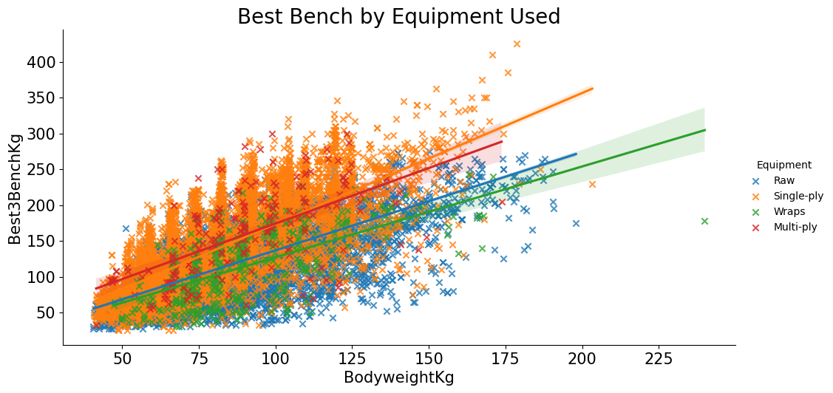

The last group of regressions and datapoints to examine based on the three major powerlifting events was the squat. The squat consists of loading the quadriceps femoris, Gluteus maximus, adductor magnus, a large triangular muscle found on the anterior side of the leg, and soleus a large muscle found on the back of the leg and several stabilizing muscles. The squat is the most fundamental movement to human daily activities as it involves a bend of the knees and is humans’ strongest movement based on the muscles involved. 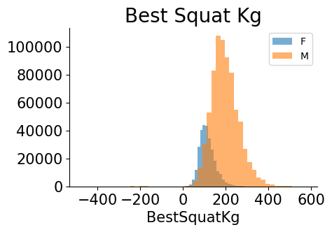

Men vastly outperformed women again on squats which at this point should not be a surprise.

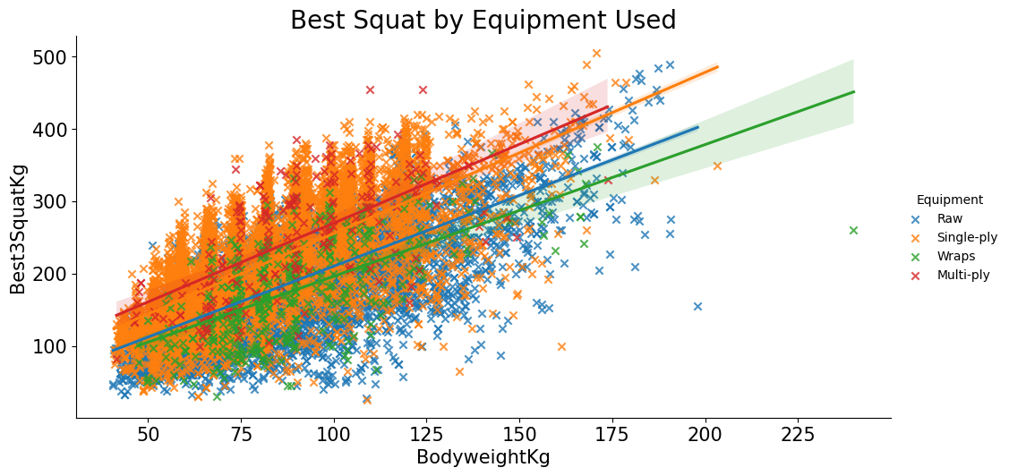

When examining the regression for squats, there seemed to be a significant 1:2 ratio of bodyweight to squat weight, which would make sense considering that squat is a fundamental movement for human activity and is widely theorized that most humans can list anywhere from 1.2 to 1.5 times their own body weight in a squatting position.

Once all the weightlifting competition data was analyzed it was time to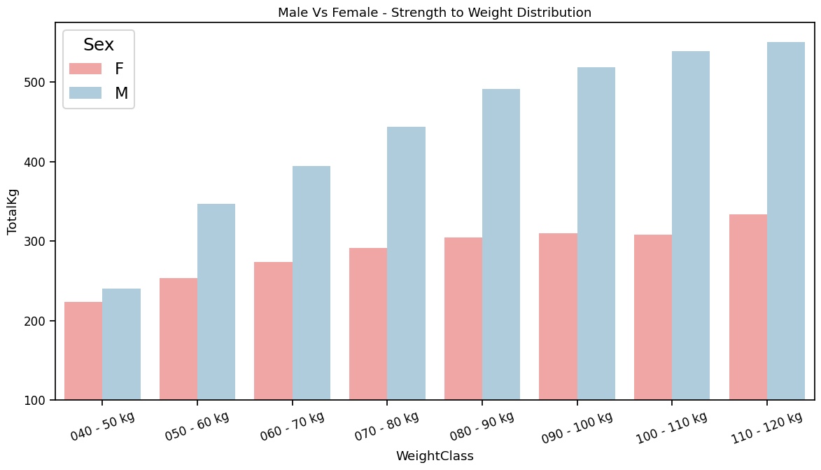 come up with some visualizations of strength to mass overall. Looking at the aggregate weight totals of males and females based on weight class to average strength distribution we can see that men significantly are stronger than women based on the same weight, however we can also deduce that as human mass increased by weight class, we also see a strength increase as well.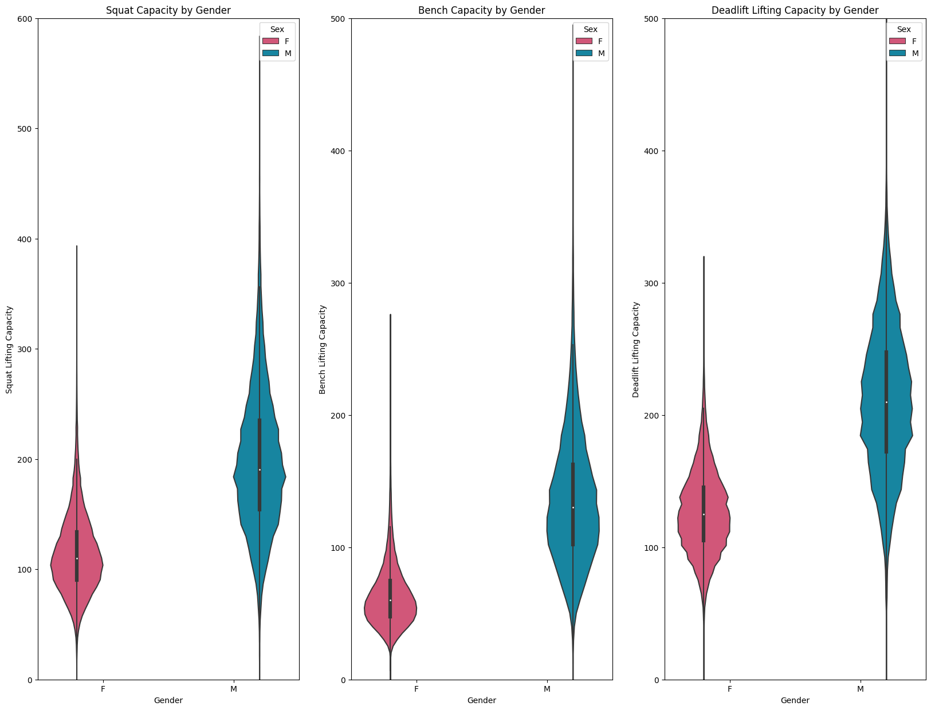

Based the three main competitive lifts we can see a massive difference between men and women based on the lifting capacity, or the amount of weight one can reasonably lift without injury with good form. This paper focuses only on what would be considered non performance enhancing drug based findings or what those call in the industry as, “Natural” it would be important to also take a look at the muscle growth strength comparison based on sex with available data that shows the differences between the squat, bench, deadlift from a natural lifter and those who are enhanced.

This paper is not meant to highlight the enhancements of performance enhancing drugs, but one of the ethical considerations was that enhanced individuals would have a significant increase in strength comparative to those who were completely clean from performance enhancing drugs. Findings wise there was not a huge difference between enhanced males and females versus natural males and females, but in a competition where oz feel like pounds and pounds feel like tons, it is important to note that a bench press of strength comparison from 25% to 24.4% is a statistically significant data point that could mean enough weight lifted to win a competition.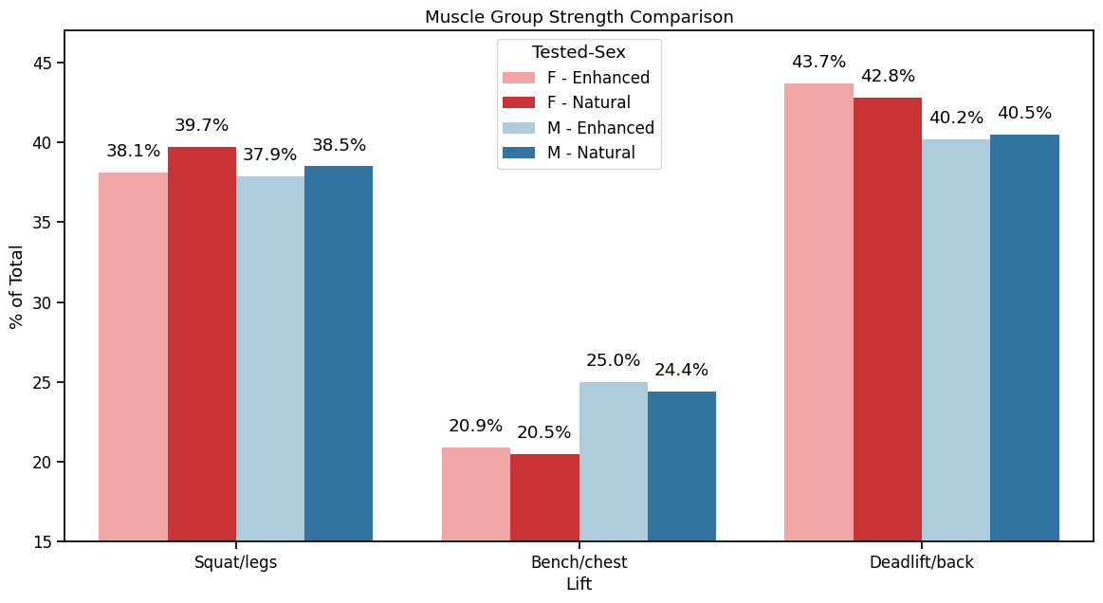

The last dataset was exploring weight training overall based on regular gym goers based in three categories, beginners or those who just started their training up to a couple years, intermediates or those who have been in a regular workout routine for a couple of years, and lastly elites, or those who have been in their workout routines for more than 5-7 years. Also explored were the types of exercises most used, along with the muscle groups trained while at the gym. First a word cloud was created to see what body parts were trained the most often.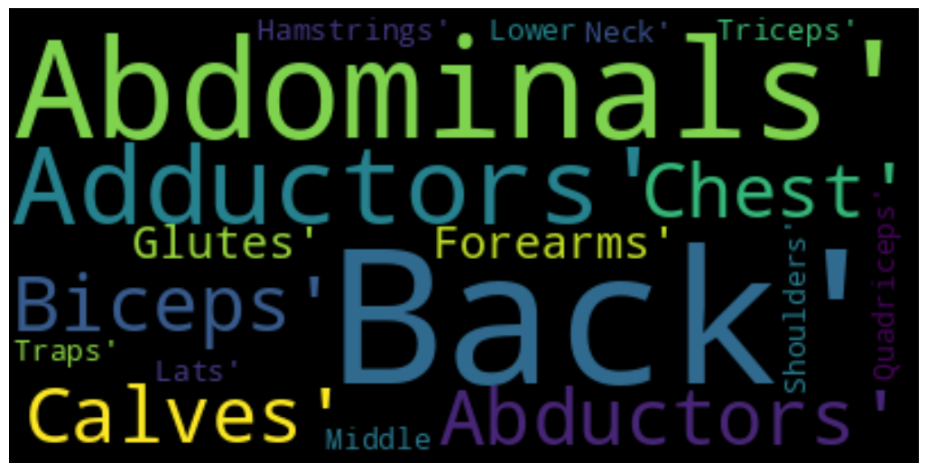

Next was to discover the amount of gym goes that were beginners, those who just started training that day or have had less than 2 years’ experience in the gym, those who had two to five years in the gym in a regular work out routine, and those gym goers that were considered elite, or those who have been in a regiment of going to the gym with five or more years of training under their belts.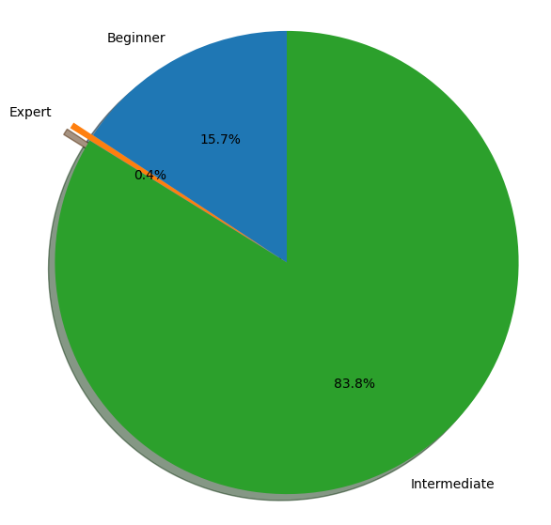

After aggregating the necessary data to come up with a pie chart, it was found that only 0.4% of all gym goers were considered experts, or elites, meanwhile the bulk of users were in the intermediate range, and only 15.7% made-up the beginner bracket. It was important to find an index of all the counts of training that occurred based on body part. A picture containing screenshot, line, font, electric blue

A graph was produced that showed that abdominals, quadriceps, shoulders, chest, and biceps were the top five muscle groups that were worked out the most while neck, abductors, adductors, traps, and forearms were the least worked out body parts. Further analysis of this data set showed the most top-rated exercises based on top five gluteus maximus exercises, 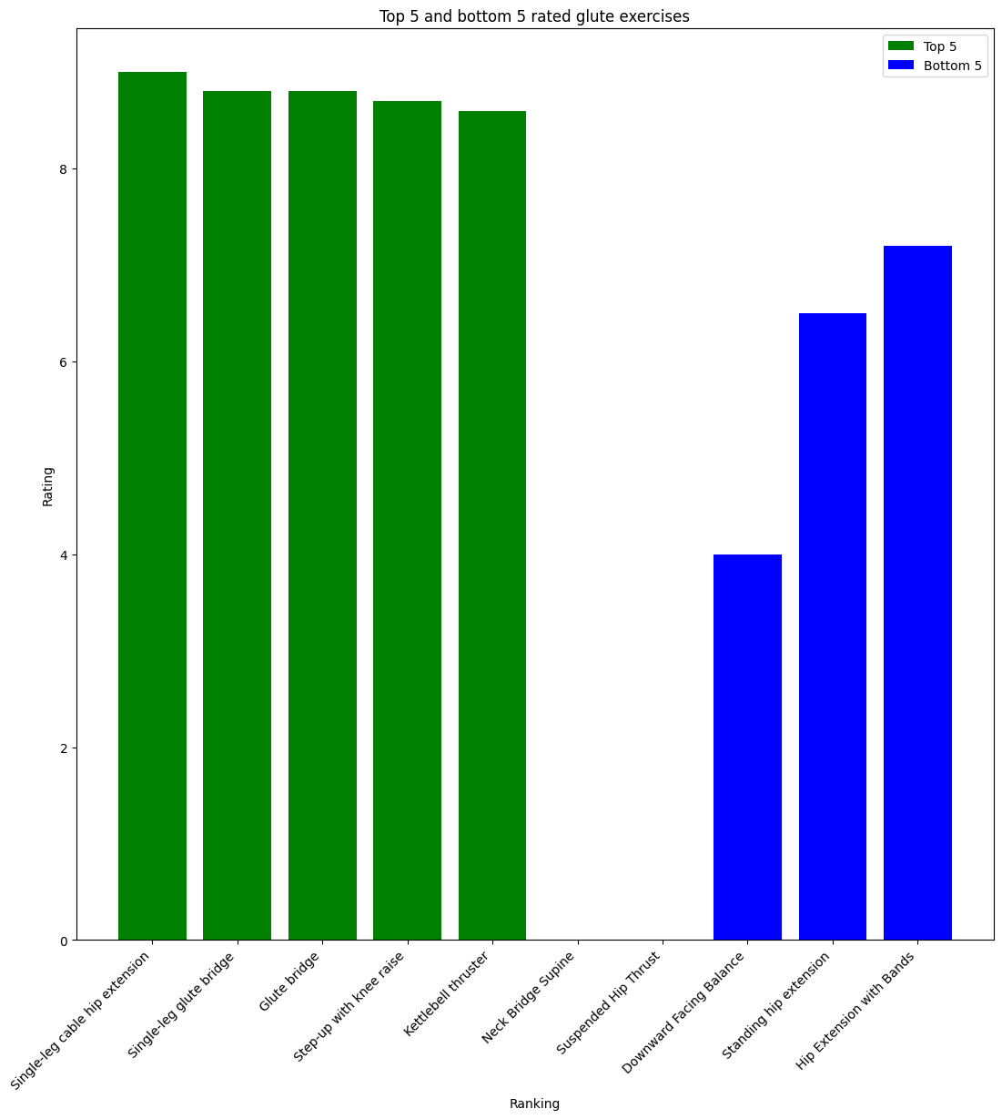

single lake cable hip extension single leg glute bridge, the glute bridge, step up with knee rays, and kettlebell thruster. Meanwhile the top five legs exercises were single leg press, barbell full squat, barbell walking lunge, 2 kettle bell front squat, and the kettlebell pistol squat.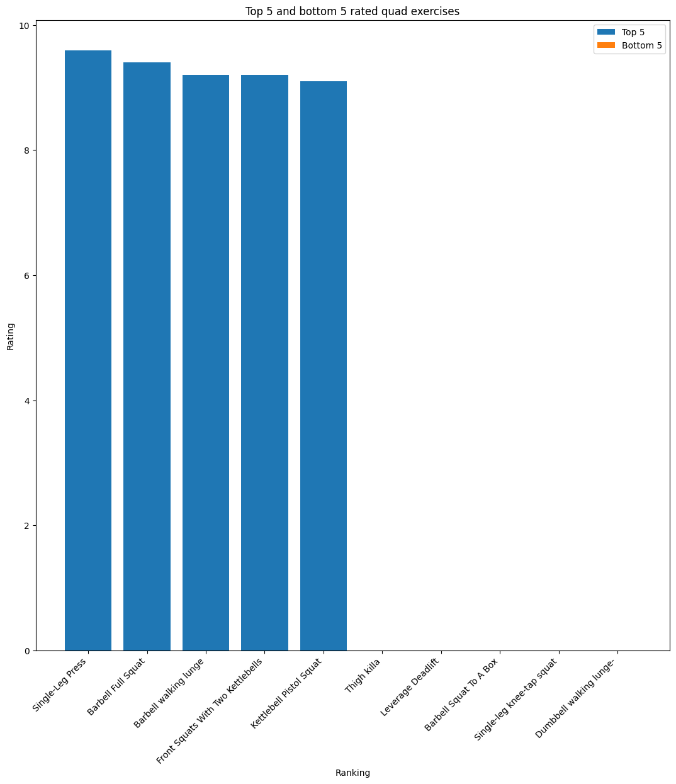

For those looking to train their backs, the top five rated back exercises were the T bar row with handle, weighted pull-ups, reverse grip bent over rows, pull-ups, and back extensions. For those looking to increase their chest the top five chest exercises were dumbbell bench presses, pushups, incline dumbbell bench press, dumbbell flies, and the close grip bench press. When taking all of the exercises indexes, the various groups of individuals going to the gym, and overall ratings for best exercises a graph was produced that showed that body weight exercise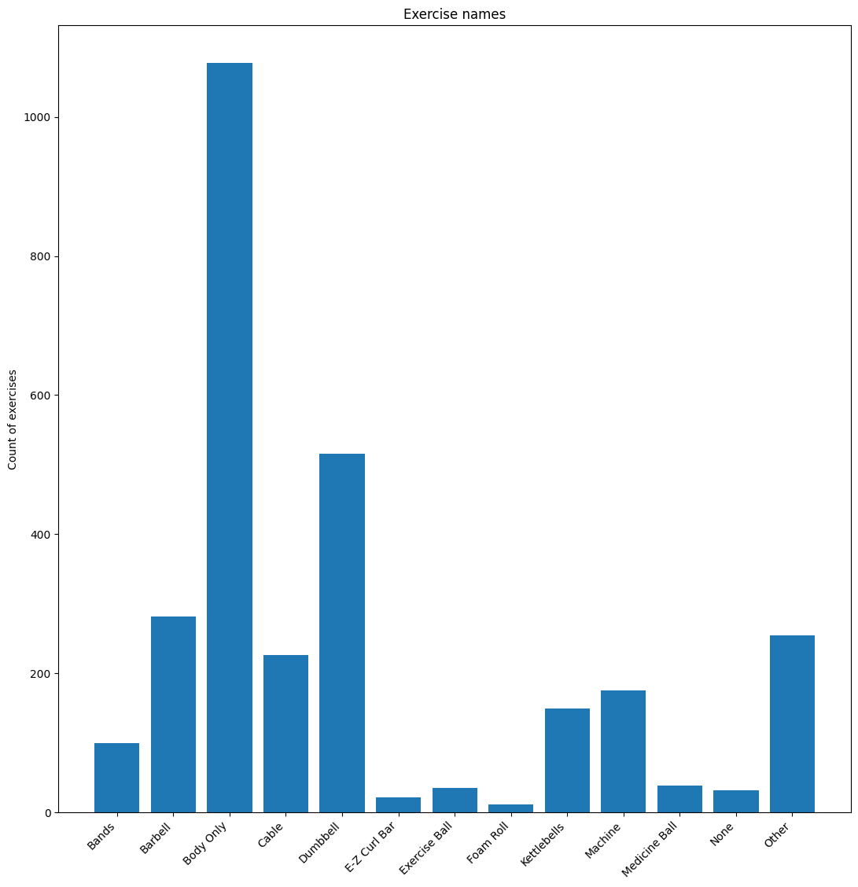were the most popular kind of exercise types and the gym, followed by the dumbbell type exercises followed by the barbell type exercises. This has significance as it shows that a combination of barbells dumbbells followed with an ample amount of body weight only style of exercise regime is the most popular for most gym goers.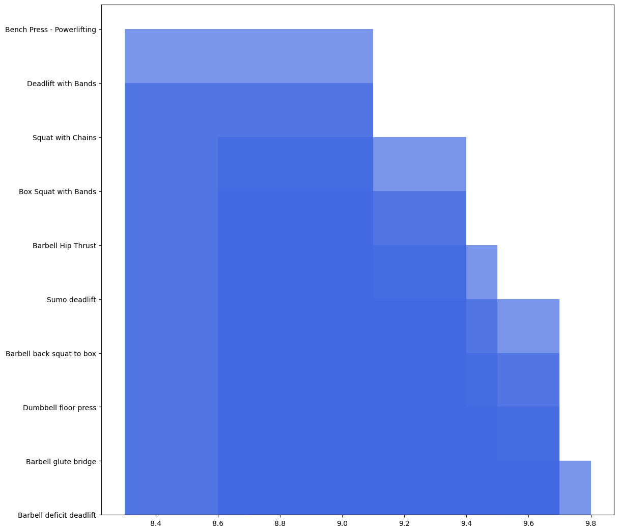

However, when isolating only the powerlifting exercises it was found that the bench press, deadlift with bands, squat with chains, box squat with bands, barbell hip thruster, sumo deadlift, barbell back squat to box, dumbbell floor press, barbell glute bridge, and barbell deficit deadlift were the most common exercises.

**Conclusion**

Weightlifting has been an excellent way for people to gauge strength and overall fitness. Exploring the data sets has been an interesting research topic that shows biologically that gender and age along with mass have a direct correlation with how much weight can be moved and for how many times based on capacity. It is also interesting to find out what others find to be the most interesting exercises to do and what body parts they tend to train overall. Exploring these datasets has reinforced several biases that are now backed up by statistical analysis to prove that gender, weight, and age have a significant role and the metabolic output tied to strength.

**References**

Andrew Heffernan CSCS, G. C. F. P. (2023, April 25). *10 of the best compound exercises for muscle and strength*. BODi. Retrieved May 7, 2023, from https://www.beachbodyondemand.com/blog/best-compound-exercises

Athni. (2017, April 5). *Exercise pattern prediction*. Kaggle. Retrieved May 7, 2023, from https://www.kaggle.com/datasets/athniv/exercisepatternpredict

Baraki, A. (2022, November 7). *Pain in training: What do?: Barbell Medicine*. Barbell Medicine | With You From Bench to Bedside. Retrieved May 7, 2023, from https://www.barbellmedicine.com/blog/pain-in-training-what-do/

Broser, E. (2019, September 5). *The 10 best compound exercises for strength*. Muscle & Fitness. Retrieved May 7, 2023, from https://www.muscleandfitness.com/workouts/full-body-exercises/top-10-compound-lifts-maximum-size-and-strength/

*Evidence mounts on the benefits of strength training*. News. (2022, March 24). Retrieved May 7, 2023, from https://www.hsph.harvard.edu/news/hsph-in-the-news/strength-training-time-benefits/

Jiunn. (2020, April 23). *Workout exercise*. Kaggle. Retrieved May 7, 2023, from https://www.kaggle.com/datasets/jiunn1998/workout-exercise

Khore. (2023, February 6). *What are compound exercises?: AFA Blog*. Australian Fitness Academy. Retrieved May 7, 2023, from https://www.fitnesseducation.edu.au/blog/education/what-are-compound-exercises/

Morris, S. J., Oliver, J. L., Pedley, J. S., Haff, G. G., & Lloyd, R. S. (2022, July). *Comparison of weightlifting, traditional resistance training and plyometrics on Strength, power and speed: A systematic review with meta-analysis*. Sports medicine (Auckland, N.Z.). Retrieved May 7, 2023, from https://www.ncbi.nlm.nih.gov/pmc/articles/PMC9213388/

Nithilaa. (2020, September 8). *Fitness analysis*. Kaggle. Retrieved May 7, 2023, from https://www.kaggle.com/datasets/nithilaa/fitness-analysis

OpenPowerlifting. (2019, April 25). *Powerlifting database*. Kaggle. Retrieved May 7, 2023, from https://www.kaggle.com/datasets/open-powerlifting/powerlifting-database

Thomas, M. H., & Burns, S. P. (2016, April 1). *Increasing lean mass and strength: A comparison of high frequency strength training to lower frequency strength training*. International journal of exercise science. Retrieved May 7, 2023, from https://www.ncbi.nlm.nih.gov/pmc/articles/PMC4836564/

Turco, L. D. (2022, August 31). *If you're short on workout time, make sure to do these 5 exercises*. Shape. Retrieved May 7, 2023, from https://www.shape.com/fitness/tips/what-are-compound-exercises

*Weightlifting for children and adolescents: A narrative review*. (n.d.). Retrieved May 8, 2023, from https://journals.sagepub.com/doi/full/10.1177/19417381211056094

Wikimedia Foundation. (2023, April 28). *Squat (exercise)*. Wikipedia. Retrieved May 7, 2023, from https://en.wikipedia.org/wiki/Squat_(exercise)